Purpose
  - The purpose of this document is to describe the procedure for assembling the kits for the small area cleaning machines.
- Scope
  - This SOP applies to all equipment assembly team members. The process applies to the following kits:
EP50167EQS0600BE1200 – Hard Surface Tool Kit
EP50168EQS0600BE1200 – Carpet and Upholstery Tool Kit
EP50170EQS0600BE1200 – Complete Master Tool Kit
- Responsibilities
  - The operations manager/supervisor is responsible for enforcing this SOP.
- Materials
  - The proper materials needed for this process are listed on the sub-assembly work order.
- Definitions

- Procedure
  - Assembling the Vacuum and Solution Hose (EP50166EQS0600BE1200)
    - Lay the vacuum hose (88962) next to the solution hose (88977). Verify that the larger coupling on the solution hose lines up with the end of the vacuum hose shown in the photo below.
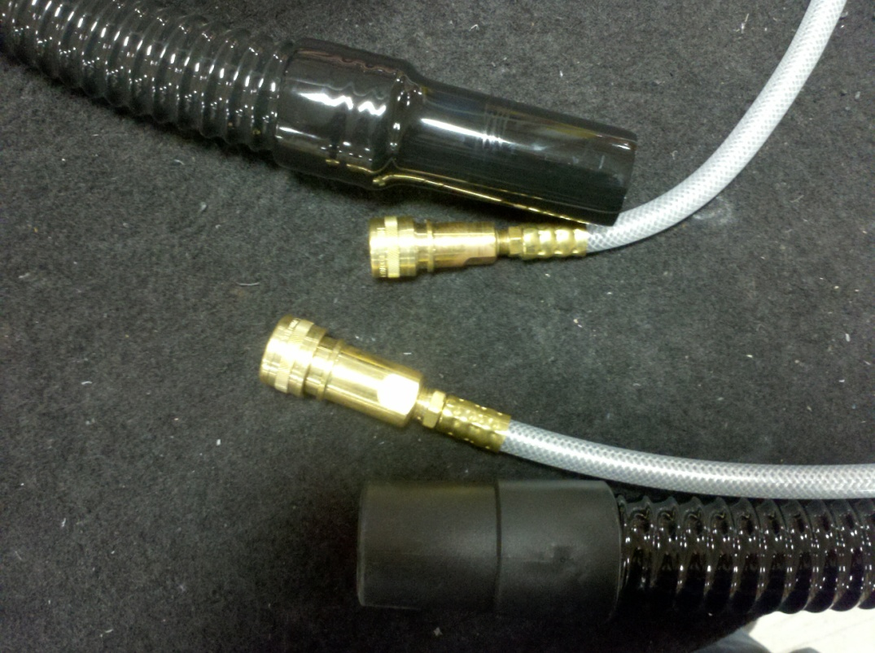
Larger Coupling with Larger Hose End

    - With 7 evenly spaced zip ties (88890), attach the solution hose to the vacuum hose. There will be extra hose sticking out from the end with the longer hose cuff.
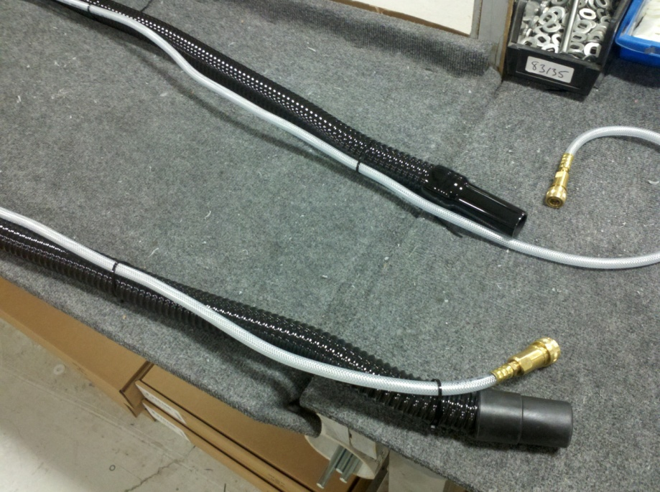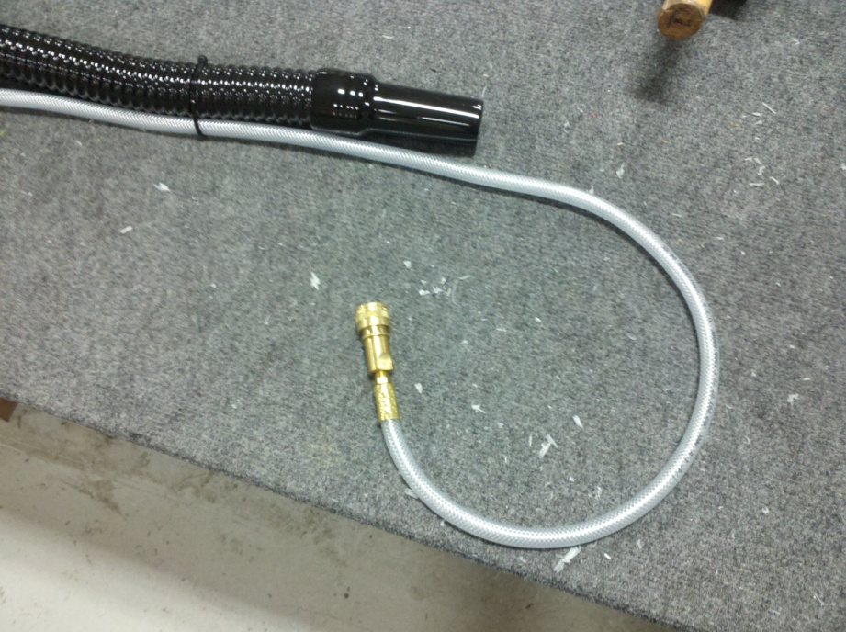
    - Clip off the extra length of zip tie.

  - Assembling the Flip Tool Brush Assembly (EP50171EQS0600BE1200)
    - Attach the mounting bar (88969) to the brush (88961) using 3 screws (89551).
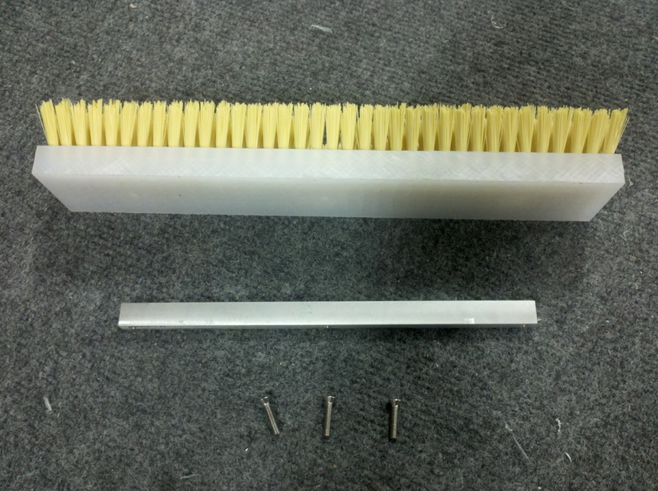
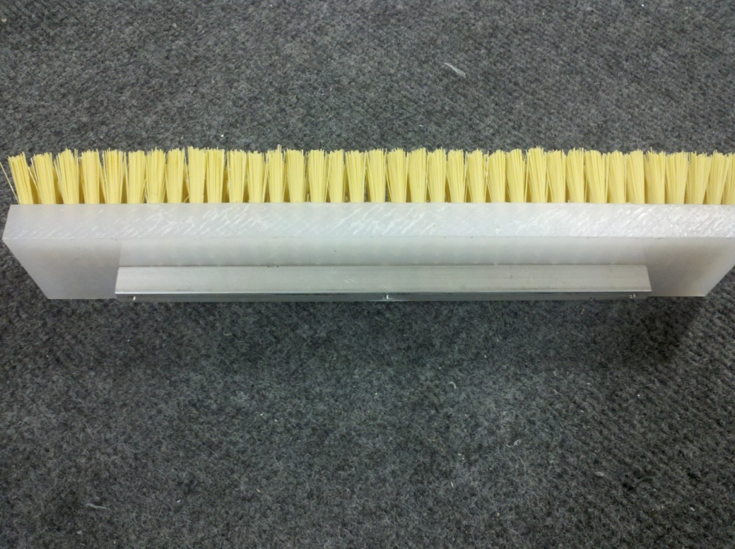
  - Assembling the Flip Tool Head Assembly (EP50172EQS0600BE1200)
    - The brush needs to be attached to the flip tool. This is done by using the brush assembly (EP50171), the flip tool (88967), and two screws (88972). Slide the brush bar between the tabs on the flip tool. Put the two screws into the holes and tighten against the bar to clamp it into place.
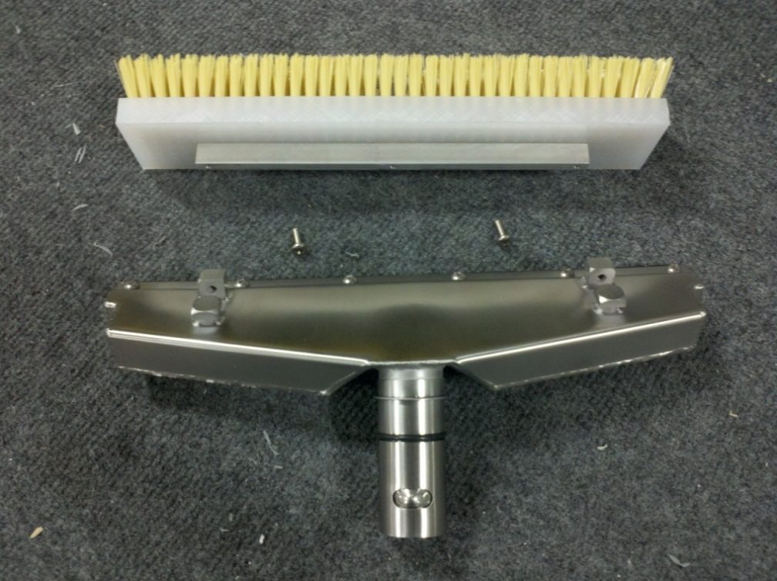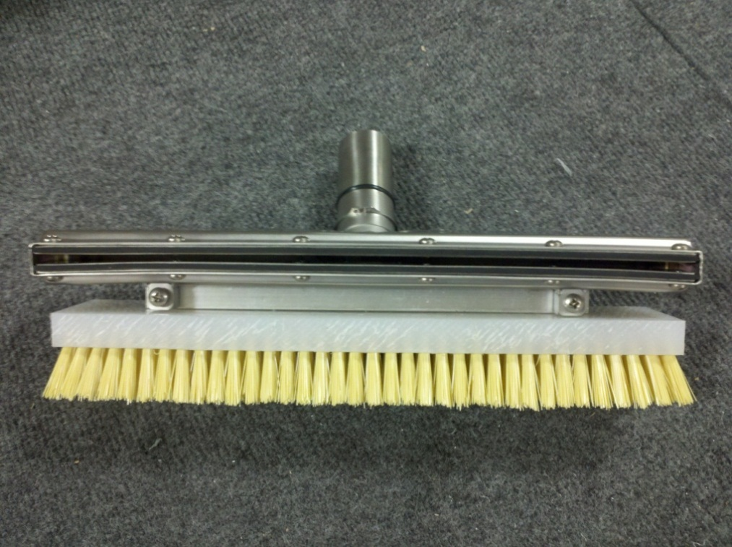
  - The complete kit now needs to be assembled. All components listed in the BOM’s below are to be placed into the box and taped shut. Write the ID numbers for the kit on the outside of the box.
EP50170EQS0600BE1200 – Complete Master Tool Kit
1-E088974EQP0600BE1200 – Wand, Vacuum, 2 Piece Assembly
1-E088964EQP0600BE1200 – Carpet Head Assembly, 12”
1-E085515EQP0600BE1200 – 3” Hand Tool (metal)
1-E088976EQP0600BE1200 – Spray Wand with Trigger & Nozzle ASM
1-E089542EQP0600BE1200 – Mesh Tool Bag
1-E089546EQP0600BE1200 – Box, Tool Kits
1-EP50166EQS0600BE1200 – Solution & Vac Hose Assembly (assem. instructions above)
1-EP50172EQS0600BE1200 – Flip Tool Head Assembly (assem. Instructions above)

EP50167EQS0600BE1200 – Hard Surface Tool Kit
1-E088974EQP0600BE1200 – Wand, Vacuum, 2 Piece Assembly
1-E089542EQP0600BE1200 – Mesh Tool Bag
1-E089546EQP0600BE1200 – Box, Tool Kits
1-EP50166EQS0600BE1200 – Solution & Vac Hose Assembly (assem. instructions above)
1-EP50172EQS0600BE1200 – Flip Tool Head Assembly (assem. Instructions above)

EP50168EQS0600BE1200 – Carpet and Upholstery Kit
1-E088974EQP0600BE1200 – Wand, Vacuum, 2 Piece Assembly
1-E088964EQP0600BE1200 – Carpet Head Assembly, 12”
1-E085515EQP0600BE1200 – 3” Hand Tool (metal)
1-E089542EQP0600BE1200 – Mesh Tool Bag
1-E089546EQP0600BE1200 – Box, Tool Kits
1-EP50166EQS0600BE1200 – Solution & Vac Hose Assembly (assem. instructions above)

- References (optional section as needed)

- Training Guide

Functional Training Groups Requiring Training
Equipment Group

- SOP Change Control

Date of Change | Reason for Change
Rev 01 - 11/19/2013 | This is the first version of the S.O.P. hence there are no revisions to this document.
Rev 02 - 1/22/2018 | Added Responsibilities Section

Approvals

Submitter/Author Approval:__________________________________ Date:______________________

Management Approval:______________________________________ Date:______________________

QAU Approval:_____________________________________________ Date:______________________

